**ASSIGNMENT 8.6**

**PROBLEM STATEMENT :**

**1.Find the top five kinds of GoogleKnowlege_Occupation people who were guests in the show, in a particular time period i.e., between '1/11/99' and 6/11/99. You need to write an UDF to compare the dates.**

**Udf :**

**Used Date to filter date between '1/11/99' and 6/11/99 by using date.after and date.before function**

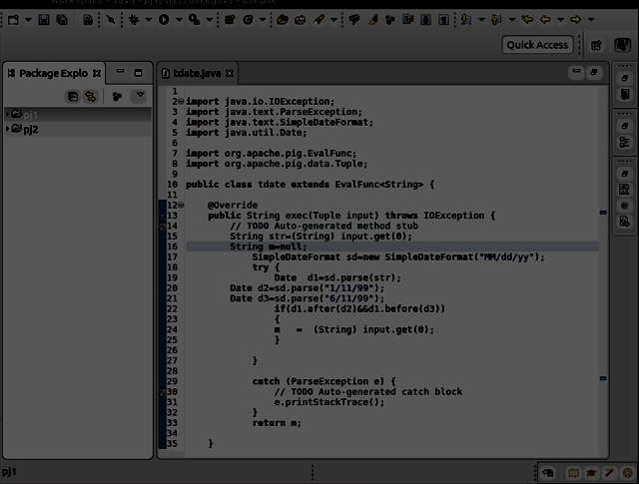

**PROCESS REQUIRED :**

**Pig Steps:**

**Step 1:REGISTERING UDF is firstly done.**

**Step2:Generate the required google knowledge column and used tdate(date column);**

**Step3:perform the filtering operation on it for not null condition**

**Step4:Obtain the group by google knowledge occupation**

**Step5:make the count that is required**

**Step6:perform the process of order by count desc**

**Step7:make it on the limit of 5**

**OUTPUT OBTAINED :**

